


American Samoa Community College
SCHOOL OF EDUCATION

Bachelor of Education (B.Ed)
in
Elementary Education

WESTERN ASSOCIATION OF SCHOOLS AND COLLEGES (WASC)
Under the joint supervision of the
Accrediting Commission for Senior Colleges and Universities (ACSCU)
&
Accrediting Commission for Community and Junior Colleges (ACCJC)

2010
Samoa Muamua le Atua
Saili Le Atamai
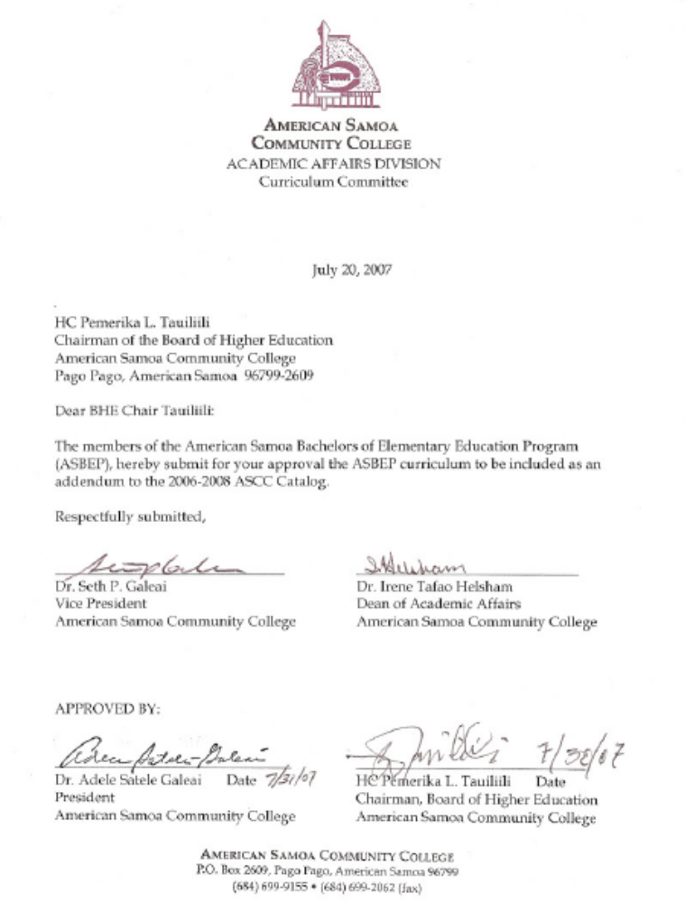
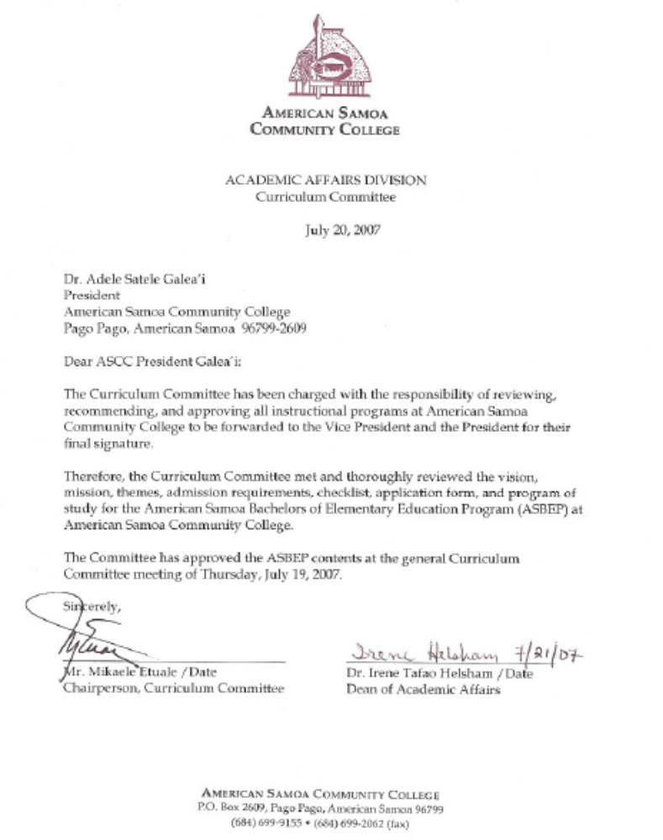


TABLE OF CONTENTS

American Samoa Bachelor of Education (B.Ed)
in Elementary Education Program (ASBEP)

- GENERAL INFORMATION
Vision 1
Mission 1
Theme 1

- ACADEMIC INFORMATION
Bachelor of Education in Elementary Education Program of Study 3
Course Descriptions 4-7

- ADMISSION INFORMATION
Admission Requirements 9
Application Checklist 10
Application Form 11-14
Tuition and Fees 10

- ASBEP DIRECTORY
Task Force Members 16
Core Faculty and Supporting Staff 16
Content Area Adjunct Faculty 17-18

- APPENDIX
Organizational Chart 20

GENERAL INFORMATION

Vision

The American Samoa Bachelor of Education in Elementary Education Program exists to meet the diverse educational needs and improve education in American Samoa. It provides a quality undergraduate program for pre-service and in-service teachers to become credentialed certified and professional educators.

The American Samoa Bachelor of Education in Elementary Education Program assumes a leadership role in providing access to innovative, research-based, and culturally responsive pedagogy and educational practices contributing to the academic and professional growth of all students. It also takes a leadership role in the advancement of the American Samoa society and the diverse humanity in the Pacific Region.

Mission

The mission of the American Samoa Bachelor of Education in Elementary Education is to meet the professional development needs of pre-service and in-service teachers enabling them to effectively teach in American Samoa and within the context of the global demands of the twenty-first century.

The program aims to:
- prepare and provide ongoing professional development of Early Childhood Education and Elementary Education teachers at the undergraduate level;
- apply knowledge in education that is research based, innovative and appropriate for the American Samoa society;
- provide service for and support to the local and regional education communities.

Program graduates will be competent in:
- teaching content area and the fundamental principles, theories and methodologies in elementary (k-8) education;
- the traditional and transitional perspectives of the Samoan culture/language and their implication in teaching and learning;
- the current technology and the application of technology.

Themes

Several themes resonate throughout the proposed curriculum. These themes provide the guidance and structure for self-reflective dialogue and evaluation of overall program effectiveness.

- Respecting diversity through a curriculum that is culturally appropriate and contextually relevant,
- A focus on enhancing student learning through the use of technology,
- A strong field-based component that provides opportunities for prospective teachers to apply gained knowledge in realistic settings,
- A focus on content-standards, literacy and research based instruction.

1

ACADEMIC INFORMATION

2

B.ED PROGRAM OF
STUDY

GENERAL EDUCATION
REQUIREMENTS CREDITS

A. Language & Literature (all courses required)
ENG 150 Introduction to Literature 3
ENG 151 Freshman Composition 3
ENG 250 Survey of Literature 3
ENG 251 Sophomore Composition 3
Total: 12 credits

B. History (a total of nine [9] credits required)
HIS 150, HIS 151 6
(American History I & II)
or
HIS 170, HIS 171 6
(World Civilization I & II)

HIS 160 Samoan History I 3
Total: 9 credits

C. Science - (a total of eight [8] credits, four credits from the Life Science, and four credits from the Physical Science below):

Life Sciences
BIO 180, BIO 180L
Biology I 4
or
BIO 155, BIO 155L
Ecology 4
or
MSC 170, MSC 170L 4
Introduction to Marine Biology

Physical Sciences
CHM 150, CHM 150L 4
Chemistry I
or
PHSCI 150, PHSCI 150L 4
Physical Science
or
MSC 150, MSC 150L 4
Introduction to Oceanography
Total: 8 credits

D. Mathematics (a total of seven [7] credits required)
MAT 150 Survey of Mathematics 3
MAT 151 Intermediate Algebra 3
MAT 250 College Algebra & Trigonometry 4
MAT 280 Calculus I 5
Total: 7 credits
3
E. Social Science
PSY 150 Introduction to Psychology 3
PSY 250 Human Development 4

Total: 7 credits

F. Arts and Humanities
SPH 153 Introduction to Speech 3
ART 150 Art History Survey I 3
MUS 160 Music Literature 3
SAM 151, SAM 151L Freshman Samoan 4

Total: 13 credits

G. Physical Education Total: 1 credit

H. Computer Science Total: 3 credits

Total General Education (GE) Credits: 60

I. Pre-Educational Core
(Qualifying courses must be numbered 150 or higher and from two separate disciplines of study)

ED 215 3
Introduction to Exceptional Children

ED 240 4
Instructional Technologies

ED 280 3
Introduction to Bilingual Education
Total: 10 credits

Total GE and Pre-ED Core Credits: 70

PROFESSIONAL EDUCATION
REQUIREMENTS CREDITS

- Core Education
ED 300 3
Foundations of Education

ED 301 3
Educational Psychology

ED 305 3
Foundations of Curriculum and Instructions
(Elementary K-8)
Total: 9 credits

- Related Content Emphasis
ED 319 3
Children’s Literature

ED 325 3
Principles of Child Development: The Samoan Child

ED 340 3
Tests and Measurements
Total: 9 credits

- Content and Methodology
ED 312 4
Teaching Language Arts in Elementary Education

ED 330 4
Elementary Mathematics Methods

ED 335 4
Elementary Science Methods

ED 350 4
Health & Fitness Education for Elementary School Teachers

ED 410 4
Elementary Social Studies Methods

ED 435 4
Elementary Creative Dramatics as a Teaching Resource

ED 440 4
Elementary Samoan Language Methods

Total: 28 credits

- Field Work
Must be approved for student teaching before Field Work

ED 490 2
Student Teaching Seminar

ED 491 10
Student Teaching Field Work

Total: 12 credits

Total Professional Education Credits: 58

Total GE and Pre-ED Core Credits: 70
TOTAL BACHELOR OF EDUCATION
IN ELEMENTARY EDUCATION
CREDITS: 128

B.ED COURSE DESCRIPTIONS

ED 215 Introduction to Exceptional Children (3)
Prerequisites: ED 150, ED 150P
This course investigates exceptionalities as defined according to federal educational guidelines, including visual impairment, hearing impairment, learning special needs, mental retardation, physically and health impaired, behaviorally disordered, communication disorders, and gifted. It is an
4

introductory course that will familiarize students with various categories of special needs. This course is a prerequisite for other special education courses and serves to prepare elementary and early childhood majors who serve children with special needs in their classrooms. Students taking this course must have completed or be concurrently enrolled in PSY 250.

ED 240 Instructional Technologies (4)
Prerequisites: ED 150, ED 150P, ICT 170
This course reviews information and communication technologies and how they are used in education. Course reviews and provides hands-on experiences with educational technologies; including, but not limited to, computer systems and peripherals, computer operating systems, and application software (word processing, spreadsheets, presentation software, graphics software, and others); Internets resources and issues; video technologies; video teleconferencing and broadcast systems; on-line course management systems; and, testing systems. The course will also review the national and local goals, standards, and issues in the use of education technologies for students, teachers, and administrators. Finally, this course will present the use and operations of the Person Digital Knowledge Box Educational Server. Students will be able to prepare on-line lesson plans for the elementary grade classrooms.

ED 280 Introduction to Bilingual Education (3)
Prerequisite: ENG 150, ENG 151
This course is designed to introduce students to a research-based theoretical framework for the schooling of language minority students. In addition, this course will examine the underpinnings of primary language development, second language acquisition, and the relationship of both to normal school achievement. The course will explore instructional methods and techniques recommended for language minority students.

ED 300 Foundations of Education (3)
Prerequisite: AA Degree ED IDP, or Instructor’s permission
This course is an Introduction to the Foundation of Education in both the United States of America and American Samoa. Pertinent issues that are related to the historical and philosophical backgrounds of education, the nature of schools, and its teaching profession will be stressed.

ED 301 Educational Psychology (3)
Prerequisites: PSY 250, AA Degree ED IDP
Educational Psychology is a required course for all education majors. This course presents an analysis of the complex factors involved in learning, individual differences, motivation for learning, the psychology of leadership, and socio-cultural factors as they affect education of children and youth.

ED 305 Foundations of Curriculum and Instructions (Elementary K-8) (3)
Prerequisite: Post AA Degree ED IDP, or Instructor’s permission
This course examines and exemplifies the relevant knowledge, skills and personal attributes of an effective teacher. Specific attention will focus on the organization of curriculum, instructional design and assessing student learning.

ED 312 Teaching Language Arts in Elementary Education (4)
Prerequisite: AA Degree ED IDP, or Instructor’s permission
A continuation of ED 257 Teaching Language Arts to Elementary Teachers I. Examination of the relevant issues of language, culture and methodology for teachers of ESL students. Consideration of language acquisition theories, linguistic approach to teaching languages, language politics and classroom application of language arts methodologies.

5

ED 319 Children’s Literature (3)
Prerequisite: AA Degree, Post AA/AS Education Certificate, ED 300
This course surveys the field of children’s literature. Emphasizing the reading and examination of all types of Children’s Literature, including cultural (both contemporary and traditional), universal and materials made available through various media. This course will examine its value to the communicative process, and defines criteria for the selection and utilization of books and instructional related materials suited to the needs and tastes of elementary school children, including exceptional children.

ED 325 Principles of Child Development:
The Samoan Child (3)
Prerequisite: AA Degree ED IDP, ED 305,
ED 301
Principles of Child Development and the Samoan Child is a required course for education majors. This course presents the basic principles of how children develop and learn in the first eight (8) years of life. Decades of research, theory and practices, and knowledge of age-related development regarding about how children learn their abilities, characteristics, and need for support, will be covered in this course. In addition, knowledge of how the Samoan child is reared in the cultural context will be explored. Teachers will observe and participate in scheduled experiences to acquire and understand the basic principles of child development. The Samoan child will be the focus of discussions, observations, and experiences planned for this course.

ED 330 Elementary Mathematics Methods (4)
Prerequisite: AA Degree ED IDP, ED 300, ED 301, MAT 250
ED 330 uses readings, case studies, instructional technology, and a school-based practicum to educate pre service and in service teachers about K-8 mathematics curriculum and pedagogy. The course seeks

to help children acquire knowledge, attitudes, and skills essential to math and technology
literacy. This course has as its focus the methods and materials for teaching elementary school mathematics. The purpose of the course is to help pre-service students become confident in their ability to do mathematics so that they can do the same for their future students. Emphasized are the content of elementary mathematics, and the methods and materials useful to teach it.

ED 335 Elementary Science Methods (4)
Prerequisite: ED 300, ED 301
ED 335 uses readings, case studies, instructional technology, and a school-based practicum to educate pre service and in service teachers about K-8 science curriculum and pedagogy. The course seeds to help students develop an understanding and appreciation of science and technology education, and the ability to help children acquire knowledge, attitudes, and skills essential to science and technology literacy.

ED 340 Tests and Measurements
Prerequisite: AA Degree ED IDP, or Instructor’s permission
This course examines the basic knowledge on the use of measurements and evaluation in the educational process. Primary focus will be given to the theoretical foundations of test and measurement development and its practical application in the construction and evaluation of tests.

ED 350 Health & Fitness Education for Elementary School Teachers (4)
Prerequisite: AA Degree, Post AA/AS Education Certificate
This Health and Fitness Education methods course will first identify the basic motor skills by examining current research on physical fitness and concurrence with the National Standards. The course will engage the teacher and students to demonstrate physical activities that are appropriate for the growing child. In addition, this course will tie together a holistic approach of covering life’s pertinent
6

health issues. Teachers will discuss health behaviors with students in an attempt to help
students create a pre-intervention of a healthy life. Teachers will strengthen their teaching skills by warming up, playing with, supervising, demonstrating, and motivating students to a holistically healthy life style.

ED 410 Elementary Social Studies Methods (4)
Prerequisite: AA Degree ED IDP, Completed all 3rd Year Course Work
This is a required content/methods course for pre-service and in-service social studies elementary teachers focusing on: 1) Purpose of the Social Studies Program for K-8 students; 2) Organizational Framework of the program per grade level; 3) Knowledge and information on personal and public issues; 4) Thinking, communicating, and working with others to contribute to American Samoa and society abroad.

ED 435 Elementary Creative Dramatics as a
Teaching Resource (4)
Prerequisite: ED 300, SPH 153, Fine Arts Cluster Elective
A required content course for pre-professional and in-service elementary education teachers focusing on: 1) Utilizing creative dramatics and theatre as the medium for integrating the visual and performing arts in K-8 subjects such as science, history, language arts, mathematics, and geography; 2) Demonstrating creative teaching and learning strategies from music, art, dance, and theatre to motivate students and to enhance their study of school subjects; 3) Developing lesson plans and their effective application for integrating the arts in field settings. This course includes a practicum.

ED 440 Elementary Samoan Language Methods (4)
Prerequisite: ED 257, ED 319, or Instructor’s permission
This course reviews theories of language acquisition introduced in ED 257 and ED 319.
Similarities and differences between literature-based and language-based

curricula are surveyed with special focus on the teaching of Samoan at K-12 applying the
whole language approach to the Samoan language teaching. The prescribed English language arts texts used as references are adapted to the teaching of Samoan.

ED 490 Student Teaching Seminar (2)
Prerequisite: Complete all 300 and 400 courses, concurrently with ED 491
This seminar course is an overview of the student teaching experience. The seminar will outline all the regulations of student teaching and explain all the guidelines. The seminar is specifically designed to all for sharing between student teachers, colleagues, and the college supervisor. Opportunities for sharing will be open to student teacher to share their concerns about their progress an to encourage and support other student teachers. The seminar is designed to serve as a forum for discussion of the relevance and real-world elementary education in American Samoa and in the United States.

ED 491 Student Teaching Field Work (10)
Prerequisite: Complete all 300 and 400 courses, student teaching approval, ED 490, concurrently with ED 490
This course provides teaching experience under intensive supervision in a public school setting. Regular observation, counseling and evaluation are provided by the ASCC School of Education faculty and field coordinator. Student teachers will receive practical experience under the guidance of supervising teachers in planning for teaching, managing classrooms, and directing learning activities of students. Student teachers are given increasing responsibility for directing the activities of the classroom group to the point of assuming full responsibility.

7

ADMISSION INFORMATION
8

ADMISSION INFORMATION

Admission Requirements

All students planning on entering a program of study towards a Bachelors degree in Elementary Education must have successfully completed the following admission requirements:

- Complete the admission requirements to the American Samoa Community College as outlined in the current General Catalog;
- Complete application requirements with the ASCC School of Education for official classification to major in Elementary Education. Enrollment for 300 and 400 level education courses applicants are required to provide verified test date and or score for Praxis I Pre-Professional Skills Test (PPST Exam);
- Complete the ASBEP General Education Requirements (70 credits), as outlined in the General Catalog with a cumulative grade point average of 2.7 or better. Students who have not met the General Education requirements will be accepted on a provisional status. Students who have completed all General Education requirements will be moved to full candidacy;
- Maintain a grade of “C” or better in ASBEP Professional Education Core Requirements (58 credits).
- Tuition fees are charged accordingly; refer to page 23 of the ASCC General Catalog 2006-2008.
9

Checklist

Before submitting application, check for the following:

Submit to American Samoa School of Education Office the following:
❒ 3 Letters of Recommendation
❒ Completed application
❒ 1 Faculty Recommendation and completed recommendation form
❒ 2 Personal References & addresses
❒ Health & TB Test (date & verified)

Pay $30.00 non-refundable application fee (check, money order, or cash) to Business Office

For additional assistance, please contact the American School of Education Office.
Call 699-9155, ext. 431/385/394/416 for information and status of application.

Tuition Cost and Fees:

Tuition cost per credit is $45 per Residence and $60 per non-Residence. Refer to “Residency Requirements” on page 4 of ASCC General Catalog 2006-2008 for residency qualification.
10

AMERICAN SAMOA COMMUNITY COLLEGE
SCHOOL OF EDUCATION APPLICATION
Bachelor of Education (B.Ed) in Elementary Education

Application Date:

PART I. BIOGRAPHICAL INFORMATION

Last Name First MI

Current Address City State Zipcode

Mailing/Permanent Address City State Zipcode

/ /
Email address Home Phone Work Phone Mobile Phone

/ /
Date of Birth High School Attended Yr. Graduated

Are you a citizen or permanent resident?  Yes
❒ No, please write your alien ID#

or passport #

ENROLLMENT: Check all that applies

❒ New Student Returning ASCC Student
❒ Continuing Student  Part-time
❒ Full-time  Transfer
❒ DOE Certification only  Other :

If graduated with AA/AS, year graduated:

Name of Institution

PART II : RECOMMENDATION
Name of full-time ASCC faculty member who will complete the recommendation form.
A full time faculty member in a department other than Education. The student needs to have been a member of a class taught by the faculty member.

Faculty Name Date

Department
Recommendation must be submitted in a sealed envelope attached with this application.

11

PART III: PERSONAL REFERENCES

List two people that may be contacted as personal references (e.g. employer, minister or instructor).

Name Mailing Address Phone

Relationship:

Name Mailing Address Phone

Relationship:

PART IV : ESSAY

Briefly answer one the following questions:

1. What makes an effective teacher? 2. Why do you want to become a teacher?

Special Needs: Student with special needs and or accommodations, contact the Dean of Student Services, Dr. Emelia Le’i for arrangements to meet your needs.

12

PART V : FINANCIAL AID

Will you be applying for Financial Aid?  Yes  No

Do you wish to apply for work study assistance?  Yes  No

To apply online for Financial Aid, go to www.fafsa.ed.gov.
ASCC Institutional code is 010010.
For additional assistance, see the ASCC Financial Aid Office.
For Veterans information, contact Ms. Fualaau Lancaster at 699-9155.

PART VIII : EVIDENCE OF NON-CONVICTION

Have you ever been charged or convicted of a crime and/or sexual offense?
❒ No  Yes, please explain:

Have you ever been institutionalized for causing physical harm to persons or property?
❒ No  Yes, please explain:

Have you ever been subject to discipline at any other institution or post secondary institution for reasons not related to academic performance?
❒ No  Yes, please explain:

13

FOR OFFICE USE ONLY

PART II : ACADEMIC RECORD (Attach the latest transcript of all college credits)

Total Semester Hours Total Semester Hours CUM
completed to date: completed at ASCC GPA

General Education Grades:
Cumulative Grade Point Average of 2.70 with no grade below “C” in the following courses:

ICT 150/ED 240 ENG 250/251 MAT 250

No Grade below a “C” in the General Education Science?  Yes  No

No Grade below a “C” in the Education Courses?  Yes  No

Program Course Grades:
Cumulative Grade Point Average of 2.70 with no grade below “C” in the following courses:

ED 150 & ED 150P ED 157 & ED 157P

ED 257 & ED 257P ED 280 ED 215 .

All grades must be listed on official transcript for grade verification.
Unofficial transcript will not be accepted.

PRAXIS (PPST) TEST SCORE:

TEST SCORE: Date taken:

I do certify that the above information in this application is true to the best of my knowledge and understand that falsification and or omission of information will be grounds for refusal of admissions and or dismissal.

Applicant’s Signature Date

REQUIRED TEST: Test results and or receipts of tests must be submitted with this application.
- Health
- TB Test

Thank you for your application to the School of Education.
Mail or drop application to the address listed below:

AMERICAN SAMOA COMMUNITY COLLEGE
SCHOOL OF EDUCATION
TEACHER EDUCATION & TRAINING DEPARTMENT
P.O. Box 2609
MAPUSAGA, AMERICAN SAMOA 96799

14

ASBEP DIRECTORY
15


American Samoa Bachelor of Education (B.Ed)
in Elementary Education
Directory

Task Force Committee
Dr. Seth P. Galea’i Vice President
Dr. Irene T. Helsham Dean of Academic Affairs
Mikaele Etuale Assistant Dean of Academic Affairs
Dr. Kathleen Kolhoff Director of Institutional Advancement
Tupua Roy Fua AS Gear-Up Director
Peseta Tialuga Seloti ASTEP Director
Dr. Lina Galea’i-Scanlan Teacher Education
Department Chairperson
Core Faculty & Supporting Staff
Dr. Lina Galea’i-Scanlan Core Faculty
Dr. Larry Purcell Core Faculty
Rosevonne M. Pato Core Faculty
Sonny Leomiti Field Coordinator
Dr. Trudie Sala Core Adjunct

Prospective Adjunct Content Area
Regina A. Meredith, M.F.A Art Methods

Trudie Sala, Ed.D. Bilingual Education
Repeka Alaimoana-Nuusa, Ph.D.

Jean Asuega, Ph.D. Clinical Psychology

Rosevonne M. Pato, M.Ed. Counseling
Annie Panama, M.Ed.

Kathleen N. Kolhoff, Ed.D.. Creative Drama

Seth Galea’i, Ed.D. Curriculum and Instruction
Trudie Sala, Ed.D.
Lina Galea’i-Scanlan, Ph.D.
Peseta Tialuga Seloti, M.A.
Tupua Roy Fua, M.Ed.
Larry Purcell, Ph.D.
Repeka Alaimoana-Nuusa, Ph.D.
Filemoni Lauilefue, M.Ed.
16

Prospective Adjunct Content Area
Milaneta Tinitali, M.Ed. Early Childhood Education

Tupua Roy Fua, M.Ed. Educational Psychology
Seth P. Galea’i, Ed.D.
Rosevonne M. Pato, M.Ed.
Irene T. Helsham, M.Ed, DPA

Sonny Leomiti, M.Ed. Field Supervision
Filemoni Lauilefue, M.Ed.

Grace T. Mareko, M.S. Information & Communications Technology
Sonny Leomiti, M.Ed.
Sal Poloai, M.Ed.
Michael Leau, M.Ed.

Teresita Almendras, M.Ed. Language Arts
Elisapeta Faalafi-Jones, M.Ed.
Peseta Tialuga Seloti, M.A.
Larry Purcell, Ph.D.
Siamaua Ropeti, M.Ed.
Ethel Sokimi, M.Ed.
Lina Galea’i-Scanlan, Ph.D.

Kathleen N. Kolhoff, Ed.D.. Literature
Peseta Tialuga Seloti, M.A.
Poe Mageo, M.Ed.

Letupu T. Moananu, M.Ed. Mathematics
Floramma Stanislaus, M.S.

Trudie Sala, Ed.D. Multicultural Education
Repeka Alaimoana-Nuusa, Ph.D.

Namulauulu Paul Pouesi, Ph.D. Music Methods
Kuki Tuiasosopo, M.A.

Ed Imo, M.Ed. Physical Education and Health
Daniel Chang, Ph.D.
Veronica Mortenson, M.Ed.

Rosevonne M. Pato, M.Ed. Psychology
Jean Asuega, Ph.D.
Demond Bell, M.A..

Kathleen N. Kolhoff, Ed.D.. Public Speaking

17

Seuamuli Mataio Fiamalua, M.Ed. Samoan Language
Peseta Tialuga Seloti, M.A.
Filemoni Lauilefue, M.Ed.

Joseph Stanislaus, M.S. Science
Matt Le’i, M.Ed.
Floramma Stanislaus, M.S.
Netini Sene, M.Ed.

K. Okenaisa Fauolo, M.Ed. Social Studies
Mikaele Etuale, M.Ed.
Elvis Zodiacal, M.A.

Iris Foster, M.Ed. Special Education
Atalina Coffin, M.Ed.
Peter Tinitali, Ed.D.
Irene T. Helsham, M.Ed., DPA

18

APPENDIX
19

ORGANIZATIONAL PLANNING STRUCTURE FOR THE
AMERICAN SAMOA BACHELOR OF EDUCATION (B.Ed)
IN ELEMENTARY EDUCATION
Vice President
Dean of Academic Affairs

ASTEP Director
Gear-Up Samoa Director

Special Consultant

Chairperson for ASCC Teacher Education Program

Assistant Dean of Academic Affairs

ASDOE Deputy Director for Instructional Services

Institutional Advancement Director
BOARD OF HIGHER EDUCATION
ASCC Vice President
ASCC President
Administrative Assistant

ASBEP
STEERING
COMMITTEE
20

20

ORGANIZATIONAL CHART INSERTED HERE



Presented & Approved by Curriculum Committee Summer 2007
American Samoa Community College

Samoa Muamua le Atua Saili le Atamai

2010

