October 18, 2021

To: Dr. Rosevonne Pato

*President, American Samoa Community College*

From: Mr. Sonny J. Leomiti

*Vice President of Administration and Finance*

Mrs. Letupu Moananu

*Vice President of Academics, Community and Student Affairs*

Subject: ASCC Proposed Resolution Plan for OCR Case No. 10142001

Talofa President Dr. Pato,

Provided for your review and approval is the proposed plan to address the College’s outstanding Office of Civil Rights (OCR) with reference to Case Number 10142001. Based on the clarification received from OCR Senior Attorney – Timothy Sell, the following actions shall be implemented by the College to address compliance and to bring to closure the outstanding case.

1. The College shall identify a Compliance Coordinator by name, email, phone number, and email address on the College Website as per USDE requirement – Section 504.
2. The College shall post its Grievance Procedure(s) on the College Website.

The following plan has been compiled:

Task: Updating of ASCC Website Information

URL: <https://www.amsamoa.edu/accessibility.html> (Accessibility Page)

Responsibility: Information Officer

Scope:

1. Remove all the Content available of the following ASCC Web Page: <https://www.amsamoa.edu/accessibility.html>

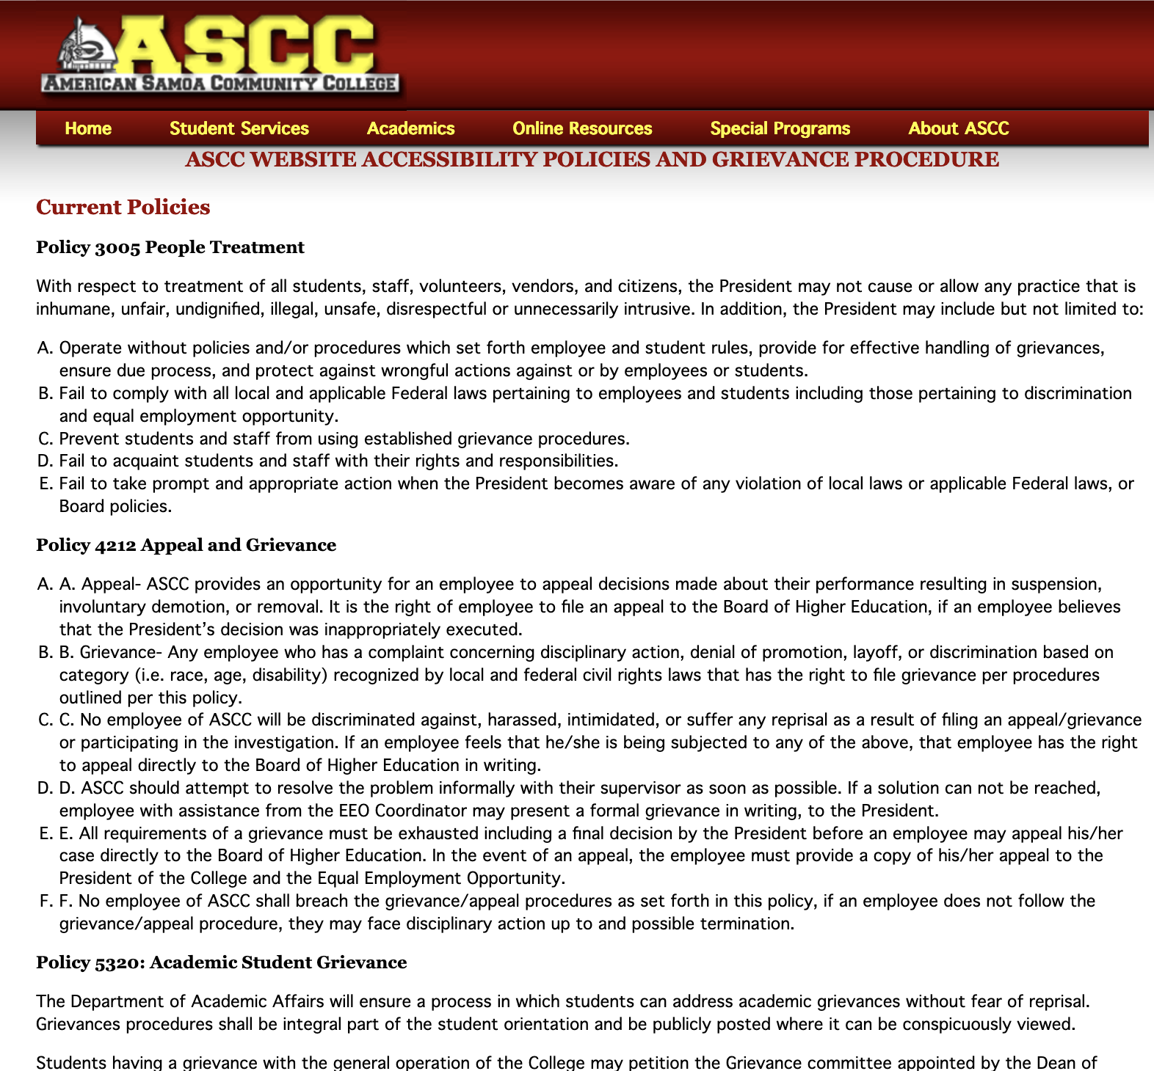

1. To change the Title of the Page from ASCC Website Accessibility Policies and Grievance Procedures to *Accessibility: Student Complaints and Grievances*:

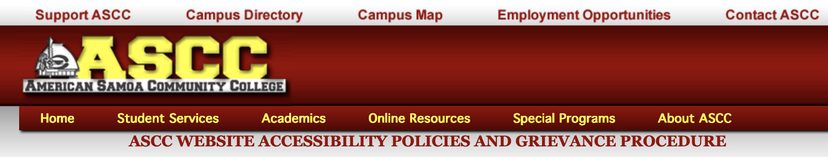

1. To include a General Narrative to describe the content of the Page:

The American Samoa Community College (ASCC) is committed to its Mission by ensuring accessibility services to the students and constituents it serves. As an open admissions College, each student is encouraged to pursue his/her academic studies without the hesitancy of unfair or improper treatment/action caused by any member of the ASCC community.

The American Samoa Community College Board of Higher Education emphasizes the importance that the community be made aware of the College’s procedures regarding online information and accessibility through its policies and College Governance in pursuant to the requirements of the Office of Civil Rights as federally mandated.

Board Policies: *(Please refer the ASCC Policy Governance Manual in the College Resources and Forms Section)*

* Policy 3005 People Treatment, p. 33
* Policy 4209 American with Disabilities Act (ADA) Compliance, p. 57
* Policy 4209.1 Reasonable Accommodation, p. 57
* Policy 4210 Non-Discrimination, p. 57
* Policy 4211 Harassment or Sexual Harassment, p. 58
* Policy 4212 Appeal and Grievance, p. 58
* Policy 5320 Academic Student Complaint/Grievance, p. 78
* Policy 5321 Student Appeal, p. 78

The College’s Student Grievance Procedure(s) is to be used when a student has been unfairly treated by a member of the College community that includes: student(s), instructor, administrator, or staff. The College identifies two separate procedures for grievances that may occur on Campus:

1. General Student Grievances: General Student Grievances include complaints about non-academic matters that include discrimination based on sex, religion, disability, color, age, and other allegations or forms of harassment such as bullying, threats, and abuse as listed in the College Catalog, pp. 31-34. Student complaints about non-academic matters should be submitted in writing to the Dean of Student Services.
2. Academic Student Grievances: Student complaints regarding academic matters should be submitted in writing to the Dean of Academic Affairs and the Dean of Student Services. (Referencing Student Handbook, p. 16).

College Resources and Forms:

1. ASCC Policy Governance Manual
2. ASCC Student Handbook
3. ASCC General and Academic Student Grievance Procedures *(Appendix 1)*
4. ASCC General and Academic Student Grievance Flow-Charts *(Appendix 2)*
5. ASCC Student Complaint Form *(Appendix 3)*
6. ASCC Request for Accommodation Form *(Appendix 4)*
7. To include the College Title IX General Statement:

Title IX is a federal (national) law in existence for combating campus violence. This requires that colleges receiving federal funding to combat gendered-based violence and harassment to ensure that all students have equal access to education.

“No person in the United States shall, on the basis of sex be excluded from participation in, be denied the benefits of, or be subjected to discrimination under any education program or activity receiving Federal financial assistance.”

Contact Information:

ASCC Title IX Coordinator: Mr. Tauvela Fale

Phone: +1 (684) 699-7834 or +1 (684) 782-3381

Email: [t.fale@amsamoa.edu](mailto:t.fale@amsamoa.edu)

College Website: <http://www.amsamoa.edu/>

College Accessibility Web Page: <https://www.amsamoa.edu/accessibility.html>