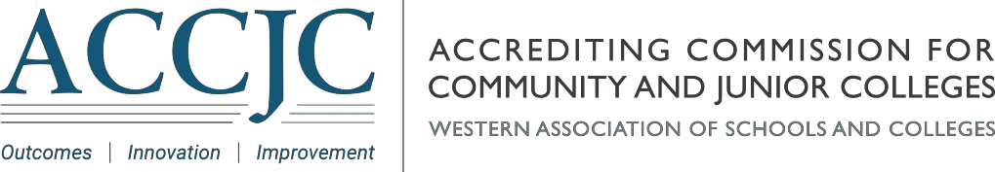

|  |  |  |  |  |  |  |
| --- | --- | --- | --- | --- | --- | --- |
| |  |  | | --- | --- | | |  | | --- | | **Date:**November 23, 2021  **Memo to:**Chancellors, Superintendents, Presidents, Accreditation Liaison Officers and All Other Interested Parties  **From:**President Stephanie Droker, Ed.D.  **Subject:**Preliminary Agenda ACCJC Open Session - Wednesday, January 12, 2022 | |  |  |  | | --- | --- | | |  | | --- | | The January meeting of the Accrediting Commission for Community and Junior Colleges (ACCJC), will be held January 12 – 14, 2022; the meeting will be conducted online via Zoom due to the continued impacts of the COVID-19 pandemic.  The Open Session of this Commission meeting will be held Wednesday, January 12, 2022, at 12:00 p.m. PST and is open to the public. Please join ACCJC Commissioners and staff in this opportunity to receive updates on accreditation processes, policies, and activities; we welcome your participation and engagement. Attached is the Preliminary Open Session Agenda. We encourage you to post this notice on your website or otherwise publicize this information to your campus community. The final agenda will be posted prior to the meeting.  Anyone can register to attend the Open Session and registration will be open and available through the end of the meeting. **However, participants wishing to make a public comment during the Open Session must register no later than Tuesday, January 11, 2022, by 5:00 p.m. PST.** The Commission has scheduled 30 minutes for public comment. Individuals’ comments are limited to five minutes, but that time may be extended at the discretion of the chair or by vote of the Commission. Each registrant will be provided the opportunity to indicate whether they would like to make a public comment during the registration process, and if so, must identify the agenda item(s) they wish to address. Please note that no reference to specific individuals or institutions may be made during public comment. Those who are making public comment must either call in by phone or have access to a computer-based microphone to make their comment.  [Click here](https://accjc.us14.list-manage.com/track/click?u=4989d678bcdbb55e553588132&id=890fdd2a4b&e=ad58fe253b) to register to attend the Open Session. Please note, if you would like to make a comment, you must register no later than Tuesday, January 11, 2022, by 5:00 p.m. PST.  Thank you in advance for your interest and participation in the ACCJC January 2022 Commission meeting. We look forward to a productive meeting.  [*Attachment: ACCJC Preliminary Open Session Agenda January 12, 2022*](https://accjc.us14.list-manage.com/track/click?u=4989d678bcdbb55e553588132&id=3fc6ff8c8f&e=ad58fe253b)In an effort to ensure wide distribution of this information ACCJC is utilizing multiple means of communication, we apologize if you receive this as a duplicate. | |  |  |  | | --- | --- | | |  | | --- | |  | | |
| |  |  | | --- | --- | | |  | | --- | | [Use this link to forward this communication to a friend or colleague.](http://us14.forward-to-friend.com/forward?u=4989d678bcdbb55e553588132&id=ebfe031fd5&e=ad58fe253b) | | |
| |  |  | | --- | --- | | |  | | --- | |  | |  |  |  | | --- | --- | | |  | | --- | | Copyright © 2021 Accrediting Commission for Community and Junior Colleges, All rights reserved. You are receiving this email because you opted in at our website or you are a staff member, Commissioner, or are affiliated with an ACCJC member institution.  **Our mailing address is:**  Accrediting Commission for Community and Junior Colleges  10 Commercial Blvd., Suite 204  Novato, CA  94949-6107  [Add us to your address book](https://accjc.us14.list-manage.com/vcard?u=4989d678bcdbb55e553588132&id=8de5af45b9)  <https://accjc.org/> | | |