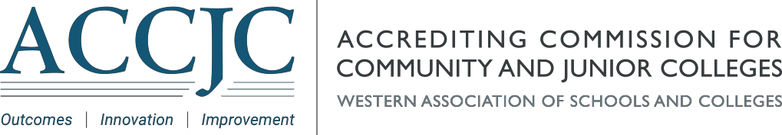
Date: |  |  | May 3, 2024
To: | Chancellors, Superintendents, Presidents, and Accreditation Liaison Officers of ACCJC Member Institutions; Other Interested Parties
From: |  | Mac Powell, President MP
Subject: |  |  |  | June 2024 Open Session Agenda and Instructions for Public Participants

The June meeting of the Accrediting Commission for Community and Junior Colleges (ACCJC) will be held June 5-6, 2024, at the JW Marriott Los Angeles L.A. Live in Los Angeles, CA.
The Open Session will be held Wednesday, June 5, 2024, at 1:00 p.m. PDT and the public is welcome to join in person or virtually. This session will focus on updates on accreditation processes, policies, and activities. All of the meeting materials including the agenda are available on the ACCJC Open Session event page.
Public Comment
The Commission has scheduled 10 minutes for public comment related to policy agenda items. No reference to specific individuals or institutions may be made during public comment. Individuals’ comments are limited to two minutes, but that time may be extended at the discretion of the Chair or by vote of the Commission.
In-person Attendees
Registration will take place onsite, outside of the meeting room (Georgia). Individuals will be asked to sign in and note if they would like to make a public comment.
Virtual Attendees
Individuals wishing to make a public comment can indicate this when they register and must identify the agenda item(s) they wish to address. Registration will be open through the end of the meeting. However, virtual attendees wishing to make a public comment must register no later than Tuesday, June 4, 2024, by 5:00 p.m. PDT.
Registration Link:https://us02web.zoom.us/webinar/register/WN_1UXQp6SURjemVCD1e92s8Q
Thank you in advance for your interest and participation in the June 2024 ACCJC Open Session.

