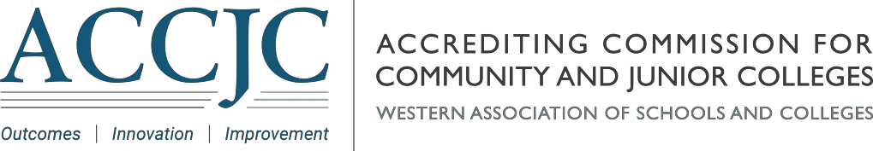

|  |  |  |  |  |
| --- | --- | --- | --- | --- |
| **ACCJC Spring 2022 Webinar Series Lineup**    Dear Colleagues,   Commissioners and staff look forward to hosting the ACCJC “Collective Dialogues: Advancing Innovation and Quality with our Institutions” webinar series this spring. The webinars will be facilitated by ACCJC Commissioner Randy Beach, Chair of the Educational Programming Committee. Here's a quick snapshot of this semester's webinars held on Tuesdays from 1:00 - 2:00 p.m. (PST/PDT):  -          **Annual Report and Annual Fiscal Report**(Tuesday, February 15th)  -          **Changes in Distance Education Regulations**(Tuesday, March 15th)  -          **The Formative Summative Peer Review Model** (Tuesday, April 19th)  -          **Standards Review Update** (Tuesday, May 17th)    Please visit our [webinar webpage](https://accjc.org/webinar/) for up-to-date information on each webinar as well as Zoom links and recordings of past webinars.    We are very much looking forward to this semester's webinars. See you in February!    Sincerely,   |  |  |  | | --- | --- | --- | | **Randy Beach**  ACCJC Commissioner  Faculty, Southwestern College | **Cindy Miles**  ACCJC Interim President  [cmiles@accjc.org](mailto:cmiles@accjc.org) | **Kevin Bontenbal**  ACCJC Vice President  [kbontenbal@accjc.org](mailto:kbontenbal@accjc.org) | |  |